Pagination Gem:-

For pagination we use the will paginate gem but this gem does not support after rails 3. So, to overcome this issue we uses kaminari gem.

Steps for pagination using kaminari gem:-

- Write gem 'kaminari' in your gem file
- bundle install
- Go to the controller action where the variable is defined. For ex:-

@products = Product.order("name").page(params[:page])

The page method tells kaminari what page we are on.

- Now, in your view file where you want the pagination, write

<%= paginate @products %>

- Reloading the page we wiil get the pagination as:-

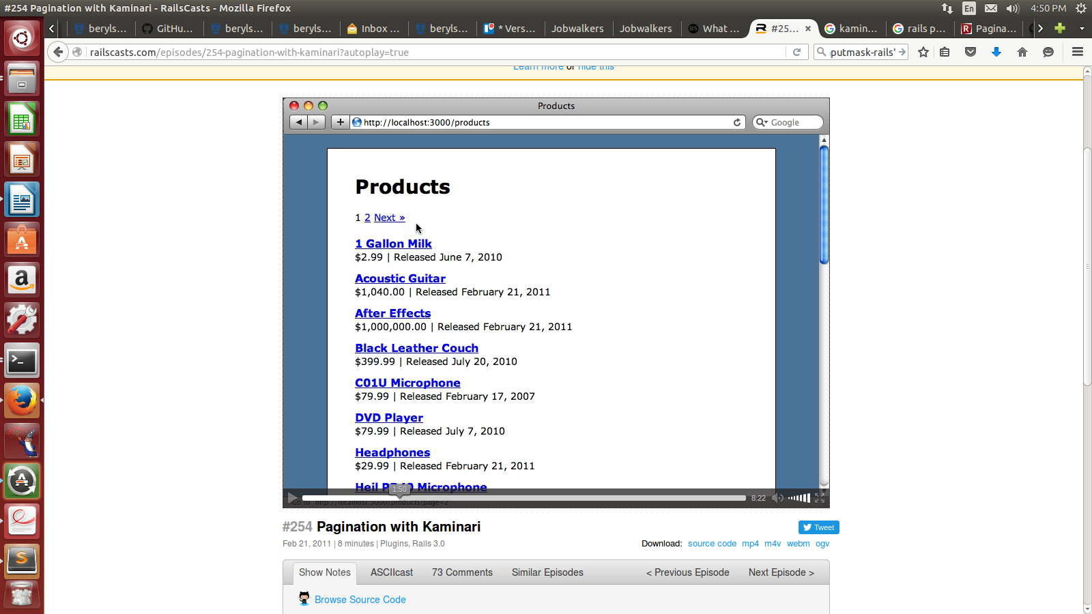

- To further modify the pagination:-
  - we can limit the number of items per page by using per() as:

@products = Product.order("name").page(params[:page]).per(5)
here,
5 is the limit per page

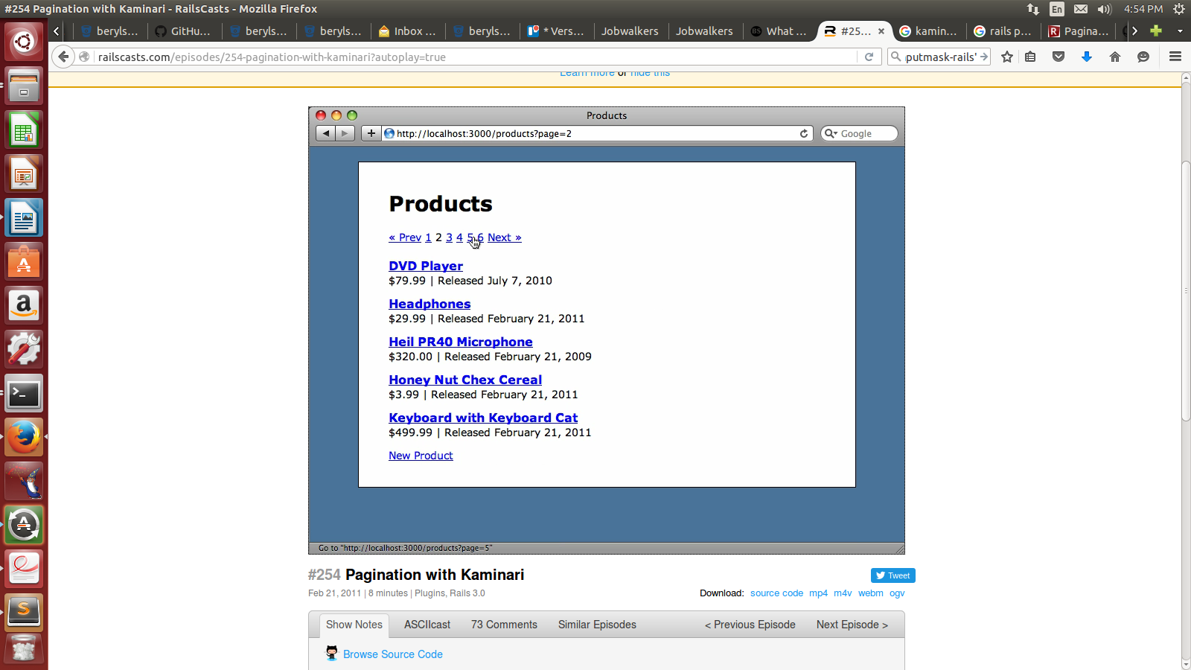
  - If we want to change the way this pagination is looking then we will use it as:-
go to config -> locals -> en.yml and update it as

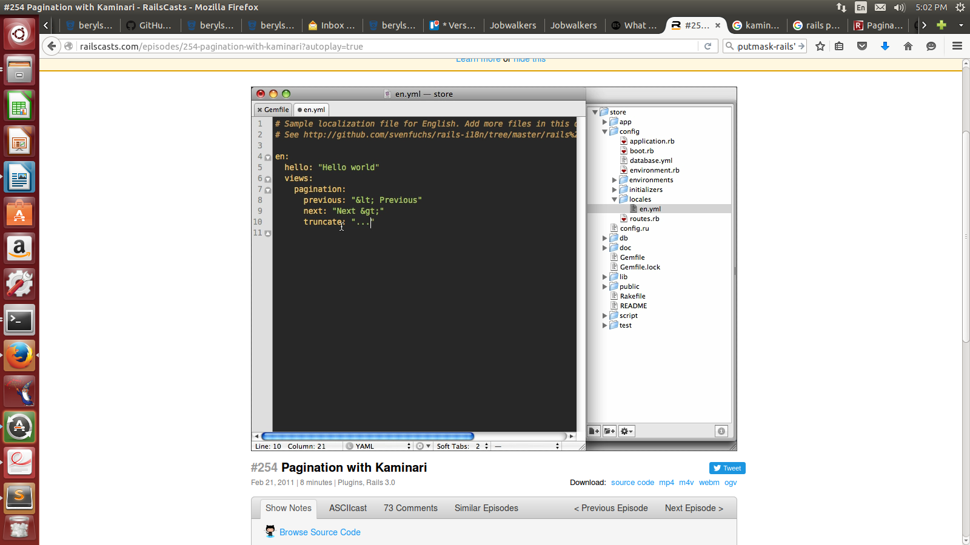

- Kaminari is a rails engine and it comes with many view files which we can override to fully customize the way it looks in our app.

- We can use various kaminari themes from github and use them as:-

rails g kaminari:views <theme_name>

by default we use default theme i.e.,

rails g kaminari:views default

- The above command will generate a bunch of partials thereby creating a kaminari directory in app --> views

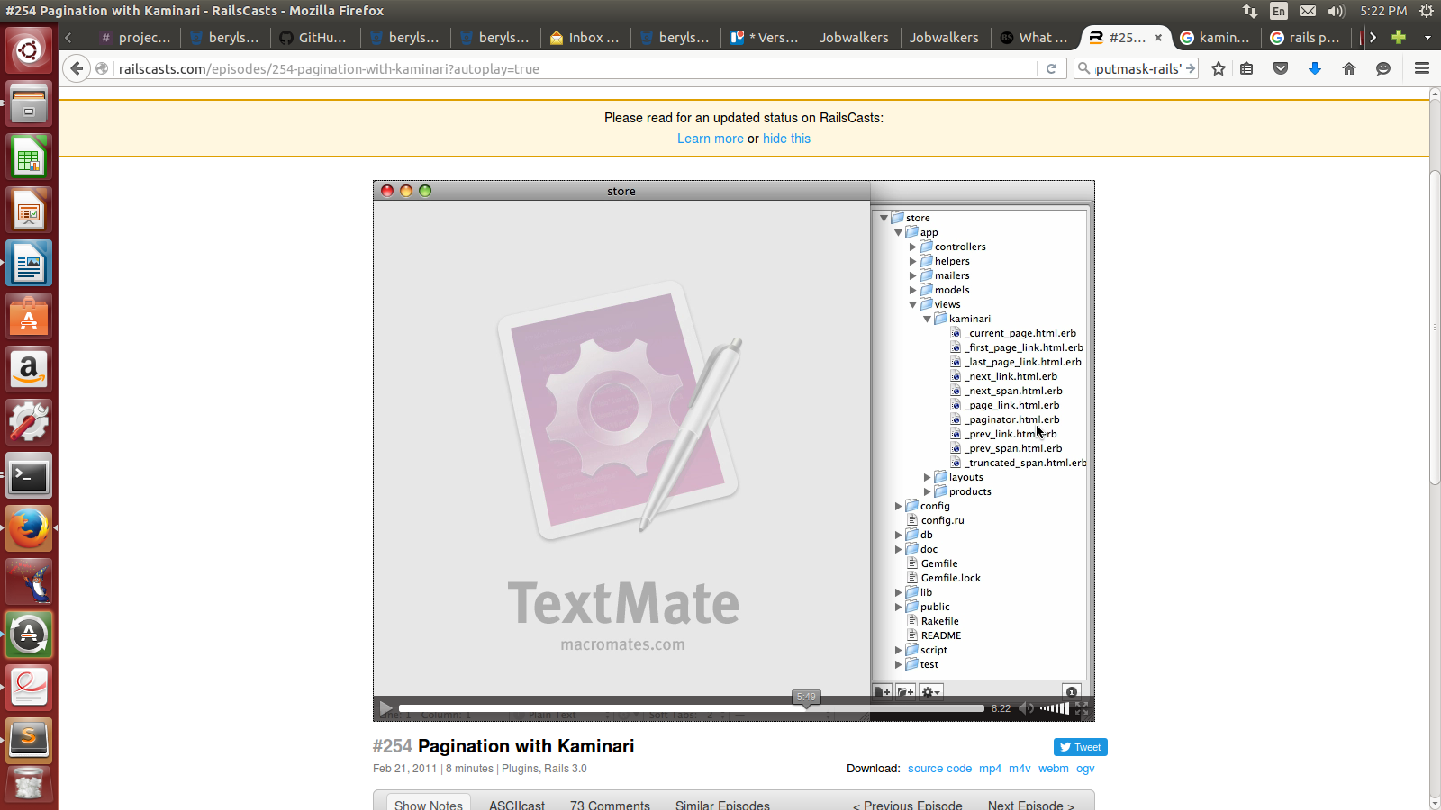

The main among this is paginator.html.erb
We can do changes in these partials.

